To (department acronym name) |  | For information (department acronym name)
ICD/ICS users (e.g. bodybuilders)

Guideline - How to request an ICD for a Chassis number/Product Individual number/Factory Order number
Contents
1 General 1
2 How to request a drawing 2
2.1 Search for a chassis 2
2.2 Request details page 4
2.3 Request drawing 6
2.4 Drawing status 6
2.5 Finalized drawing request 7
3 Failed drawing request 9
3.1 Problem with sending a request support e-mail 11

1 General
This manual provides general information about how to work with ICD/ICS application as an end-user (e.g. as a bodybuilder) and covers how to request an ICD drawing (Individual Chassis Drawing) for a specific Scania chassis.

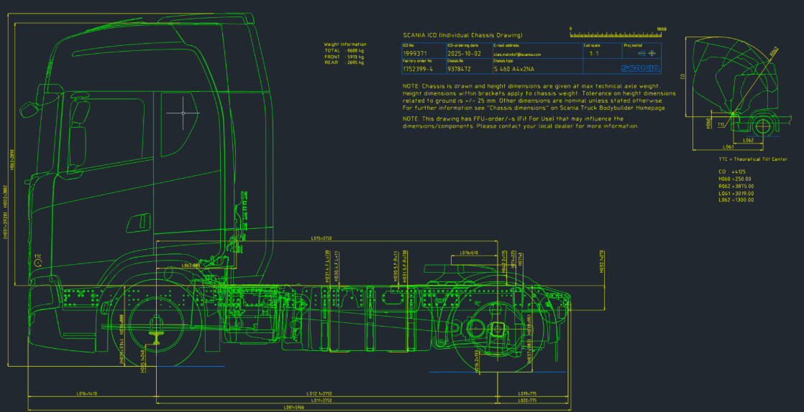

ICD/ICS application link: https://icdics2.scania.com/

2 How to request a drawing
The first step is to search for a chassis (2.1) and ne next step is to request the drawing (2.2).

2.1 Search for a chassis
Select Chassis number (Ch no., 7 digits) or Product Individual number (PI no., 8 digits) in the search field. Enter the number and press “Search” in the main page, see Picture 1. The Request details page opens up for this specific chassis.

The main page shows all drawing requests for a user. One row represent an ICD request for one specific chassis.

Note! If a drawing request already has been done for a chassis by user A, this request will not be shown in the list of requests for user B.

Picture 1. Main page. Search for a Chassis number or Product individual number.
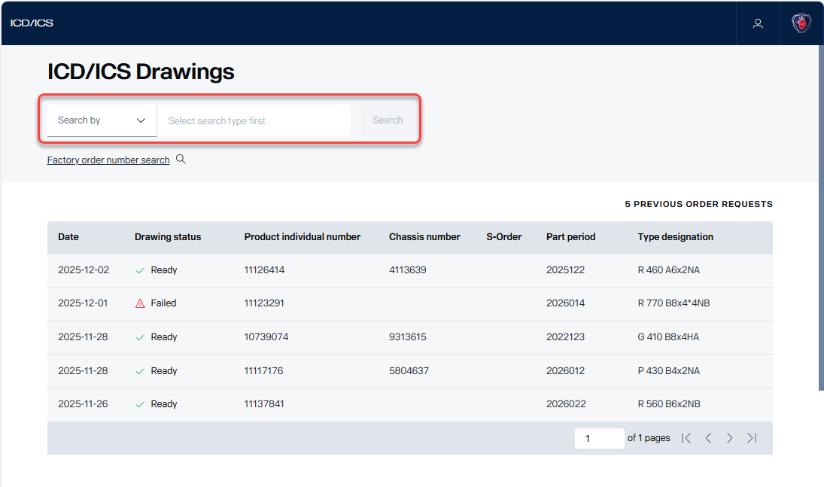

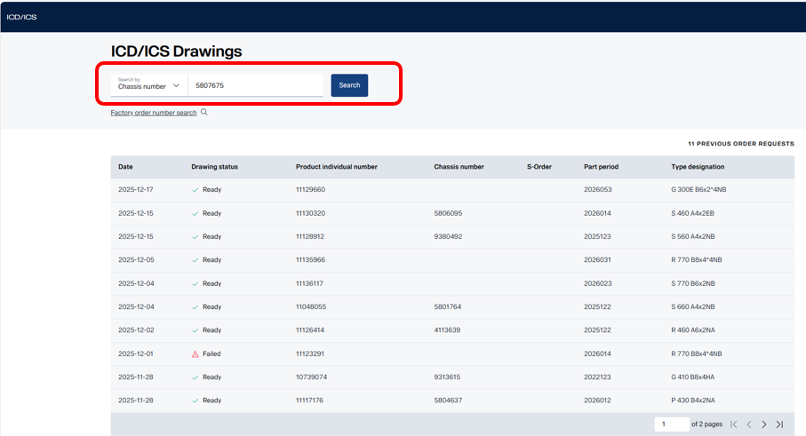
It is also possible to search by Factory order number. Click on “Factory order number search”, see Picture 2. Then a new dialog box opens, see Picture 3.
Enter Factory order number (FO no., 7 digits) and press “Search”. Click on a PI number. The Request details page opens up for this specific chassis.

Picture 2. Main page. Search for a Factory order number.
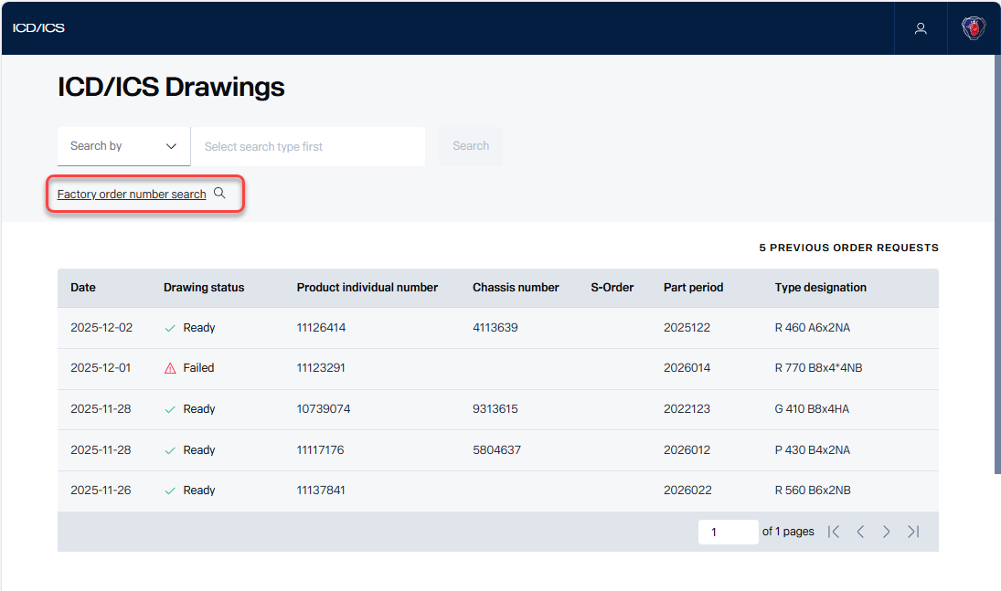

Picture 3. Main page. Search for a Factory order number.
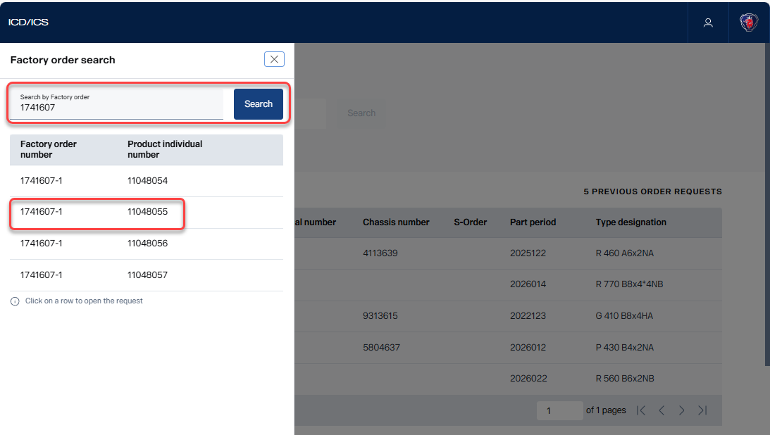

2.2 Request details page
The Request details page opens up for that specific Ch no. or PI no. or FO no.
See Picture 4 for Preliminary drawing and Picture 5 for Definitive drawing.

Preliminary drawing
When a request is done for a PI no. or FO no. (and Ch no. doesn’t exists), then the ICD is Preliminary and “Preliminary delivery date” is shown, see Picture 4.
“Request definitive drawing” informs the user about the earliest date to request a Definitive drawing.

Picture 4. Request details page. Request drawings tab. In this case the ICD is already requested and the ICD can be downloaded.
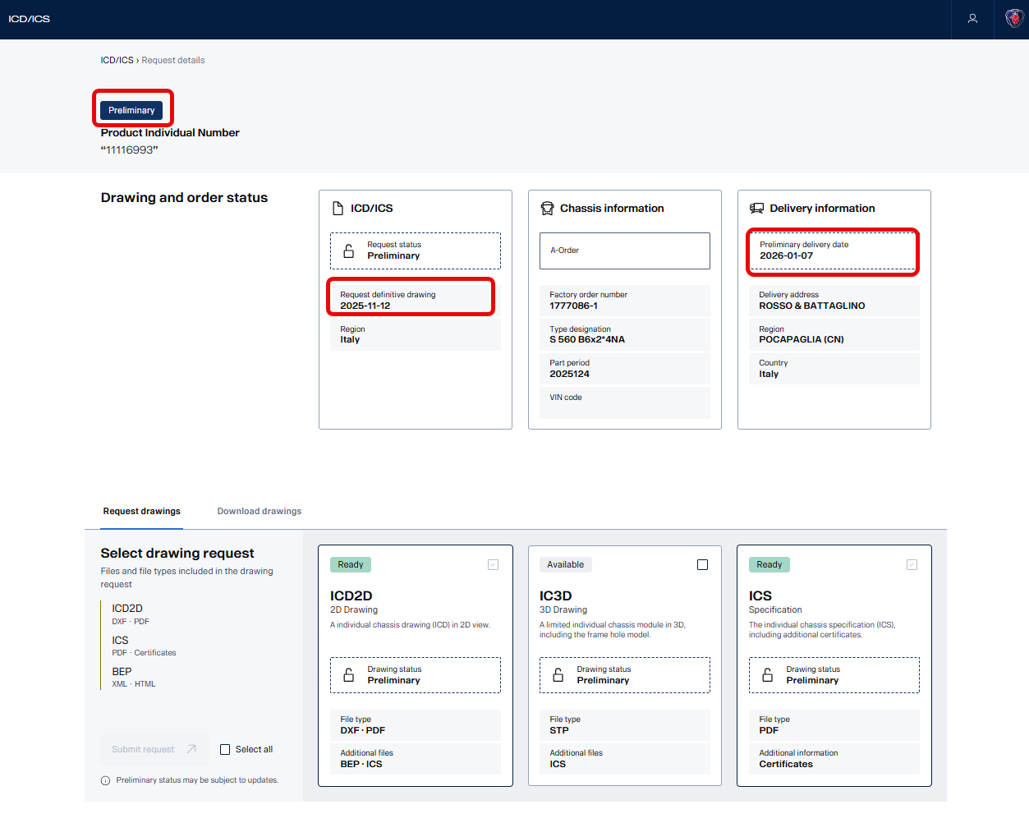

Definitive drawing
When a Ch no. exists then the ICD is Definitive and “Definitive delivery date” is shown, see Picture 5. A Definitive drawing can be requested approx. six weeks before the “Part period” (assembly of the chassis).

Picture 5. Request details page. Download drawings tab.
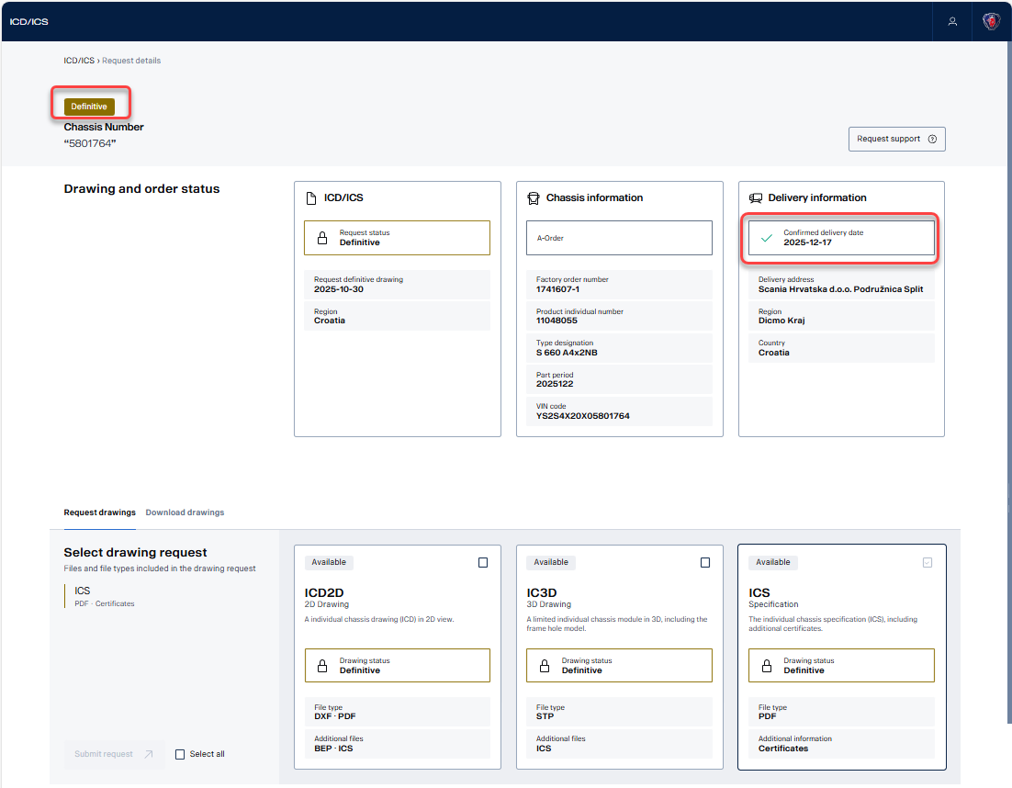

2.3 Request drawing
Select the check box if you want to request an ICD or an IC3D, see Picture 6.
If you want to request both ICD and IC3D use check box Select all. The ICS is automatically generated when a request is done and can’t be requested as a specific item.
Press “Submit request” to continue, see Picture 7.

Note! If there already exists an ICD and you want to request an IC3D use check box IC3D and press “Submit request”, see Picture 7.

2.4 Drawing status
There are four types of drawing status. The status is shown in the Request details page and in the Main page. Picture 6 shows that ICD, IC3D and ICS are Available to request. Picture 7 shows that ICD and ICS are Ready and IC3D drawing is Available to request.

 | Available (grey) | No request is done. Possible to request.
 | In Progress (blue) | Request is in progress. The ICD/ICS application is generating the ICD.
 | Ready (green) | Request is finalized and the requested item (ICD and/or IC3D) is generated.
 | Failed (red) | Request has failed.

Picture 6. Request drawing.
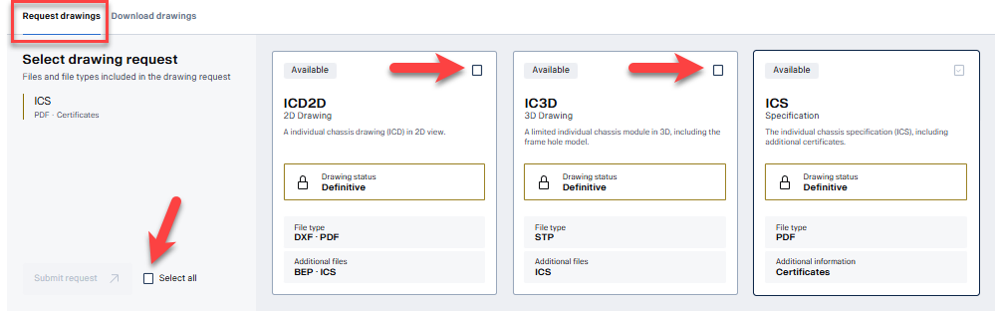

Picture 7. Request drawing.
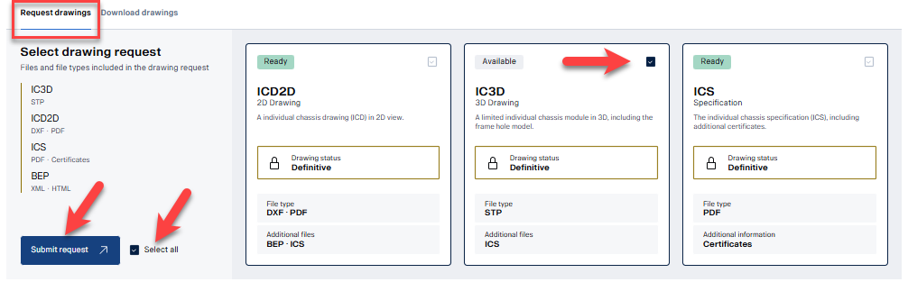

2.5 Finalized drawing request
When the drawing request is Ready you see the requested items in the “Download drawings” tab, see Picture 8.
Five or six items are generated: ICD (dxf-file, pdf-file), IC3D (STP-file), ICS (pdf-file) and BEP (html-file, xml-file). Click on a button to download a file. “Download all files” delivers all files in a ZIP-file.
The download file name corresponds to the PI no. and the date and time when the request was done. ICS language can be selected.

In the Main page you can also see that the drawing request is Ready, see Picture 9.
You will also receive an e-mail, see Picture 10.

E-mail reply
When the drawing request is Ready you receive an e-mail from noreply@ext.scania.com, see Picture 10.
There are five or six items that can be downloaded via the “Download ZIP-file” button. (If you forward the e-mail, anyone can download the ZIP-file). The ZIP-file name corresponds to the PI no. The ZIP-file is valid for seven days. An error message will appear if “Download ZIP-file” is used after the expiration date.

Picture 8. Download drawings.
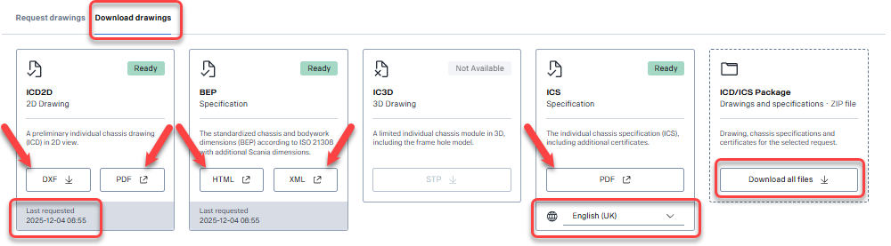

Picture 9. Main page.
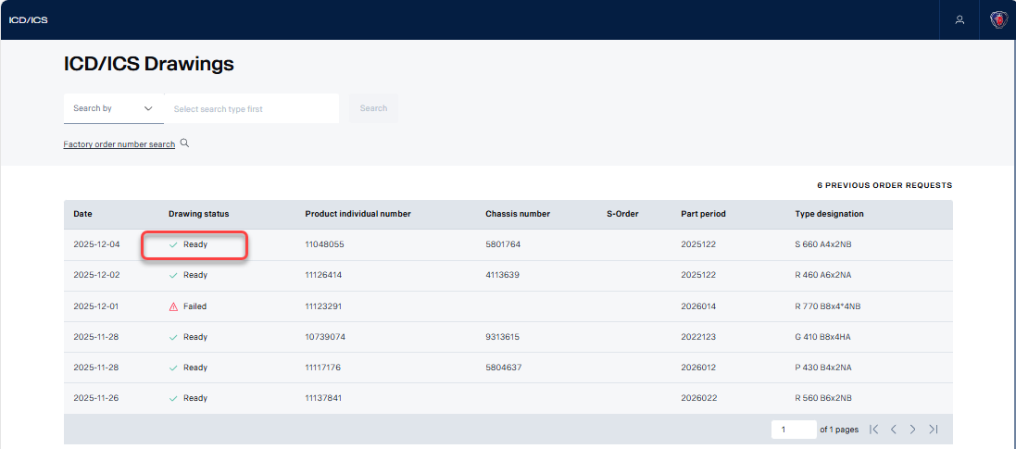

Picture 10. E-mail reply.
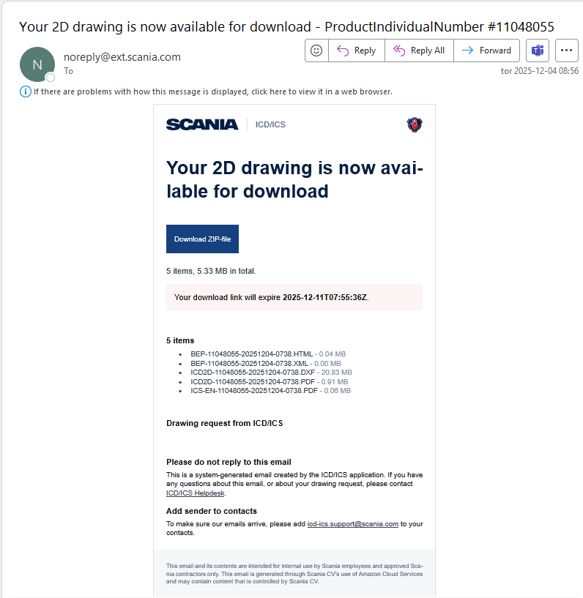

3 Failed drawing request
A failed drawing request is visualized in the Main page, see Picture 11, and in the Request details page, see Picture 12. To get support click on “Request support” button, see Picture 12.
A pop-up window will ask the user to “Create e-mail” and to type a message (optional). An e-mail is created with auto-generated text about the drawing request, see Picture 13.

Type your message above the auto-generated text (optional). Send the e-mail to the pre populated
e-mail address ICD/ICS support, icd-ics.support@scania.com.
Note! Do not edit the auto-generated text.

Picture 11. Main page, failed drawing request.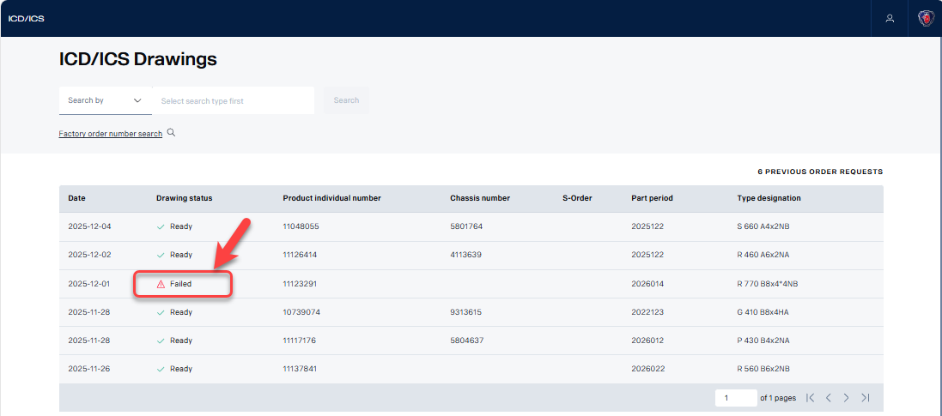

Picture 12. Request details page. Failed drawing request. “Request support” button.
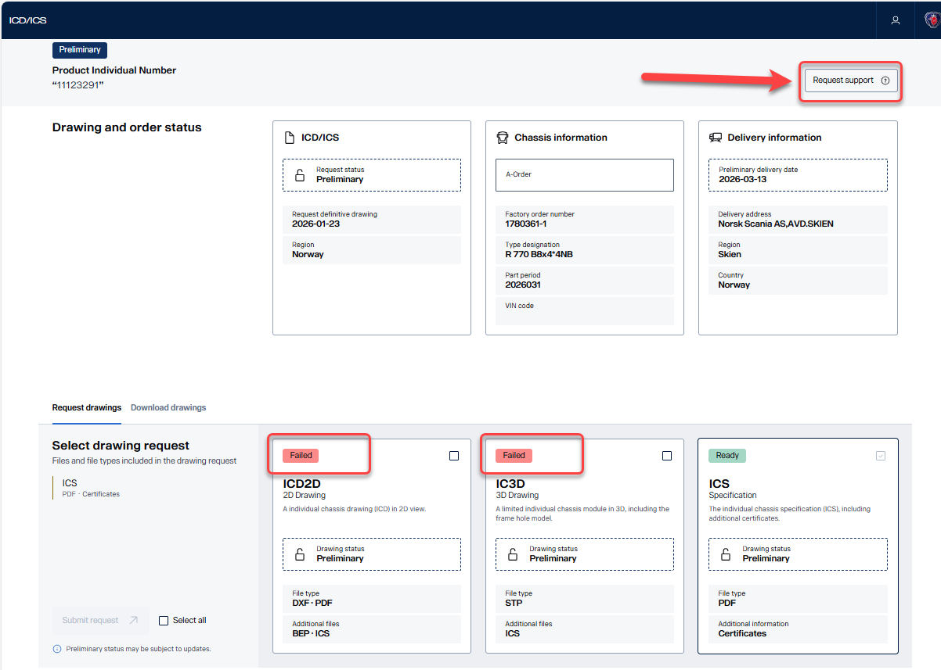

Picture 13. E-mail. Send to ICD/ICS support, icd-ics.support@scania.com.
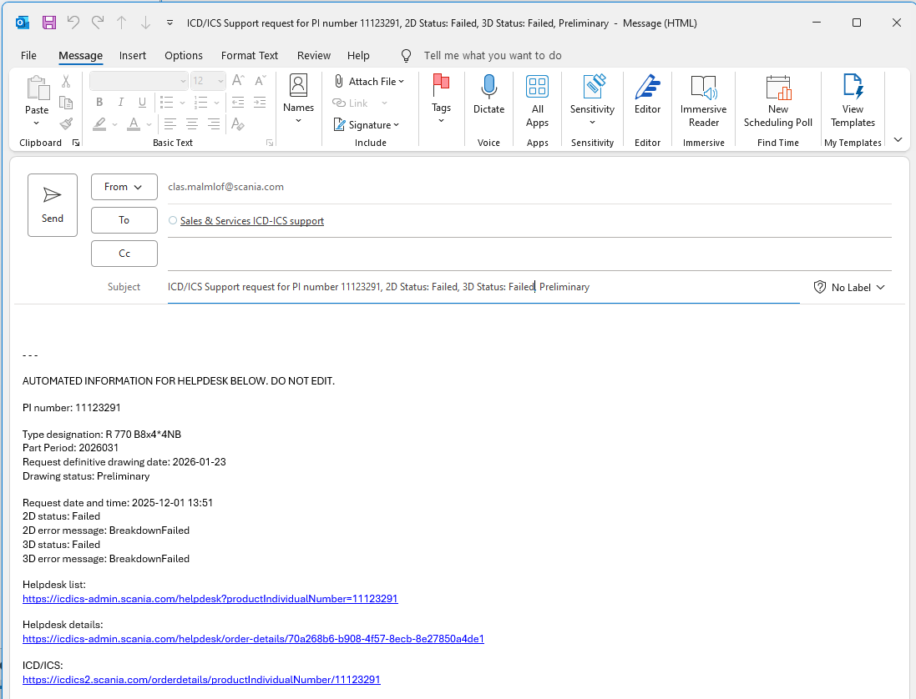

3.1 Problem with sending a request support e-mail

If an error message appears, see Picture 14, after clicking on Create e-mail you need to set the standard app for opening e-mails. See link https://support.microsoft.com/en-us/office/make-outlook-the-default-program-for-email-contacts-and-calendar-ff7990c4-54c4-4390-8fe3-c0285226f021

Picture 14
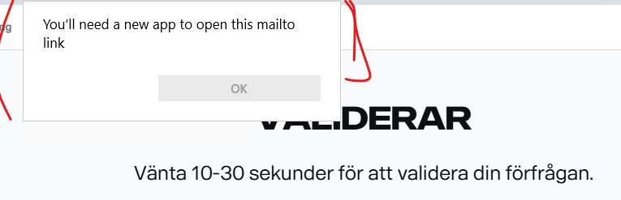

You can also use this guideline below for how to change the standard app for opening an e-mail.
- Open Settings in Windows (Picture 14).
- Select Apps and then press Default apps (Picture 14).
- Write “MAILTO” in the text field “red rectangle” (Picture 15)
- Now you can see what e-mail app that is default and what e-mail app you can select to fix your problem. (Picture 15).
In this shown case the “New Outlook” was default, which was wrong. So to fix the problem the “Old Outlook” must be selected to be default from the pop-up window at the right side (Picture 15).
- Picture 16 shows a correct selected default app for e-mail.

Picture 14

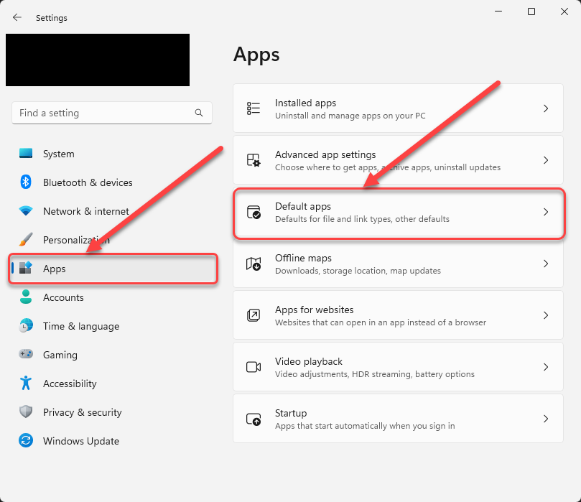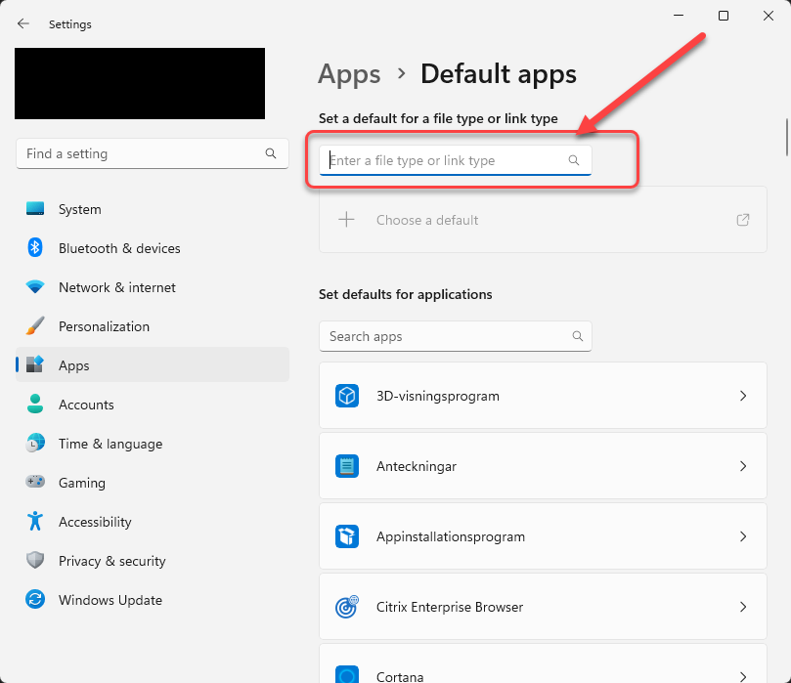
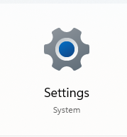

Picture 15
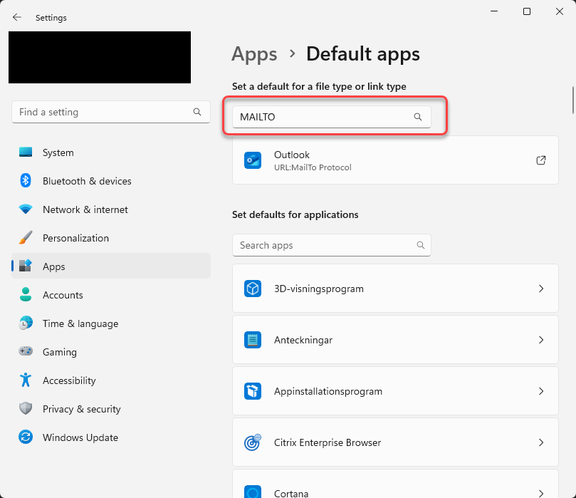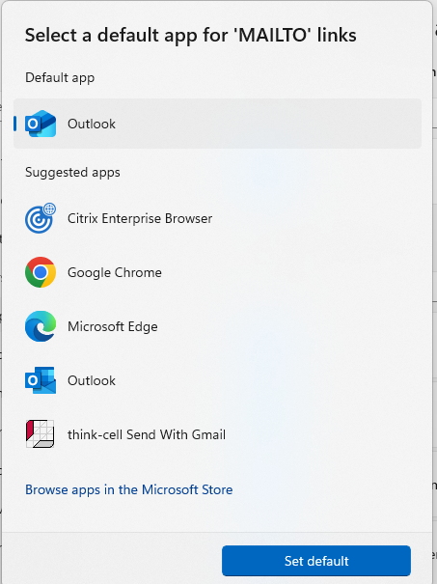
Select “Old Outlook”.
The default app for
e-mail (New Outlook).

Picture 16
